**PORTFOLIO**

(A Website Describing My Profile)

**A PROJECT REPORT**

***Submitted by***

**TRISHA CHOWDHURY**

***in partial fulfilment for the award of the degree***

***of***

**BACHELOR OF TECHNOLOGY**

**IN**

**COMPUTER SCIENCE ENGINEERING**



**Lovely Professional University, Punjab**

**12409319**

**NOVEMBER 2024**

**PORTFOLIO**

(A Website Describing My Profile)

**A PROJECT REPORT**

***Submitted by***

## TRISHA CHOWDHURY

**(12409489)**

***in partial fulfilment for the award of the degreeof***

## BACHELOR OF TECHNOLOGY



## Lovely Professional University, Punjab

### NOVEMBER 2024

**Lovely Professional University, Punjab**

## BONAFIDE CERTIFICATE

Certified that this project report **“PORTFOLIO (A Website Describing My Profile)”** is the bonafide work of **TRISHA** who carried out the project work under my supervision.

**SIGNATURE**

**CLASS MENTOR**

**HEAD OF THE DEPARTMENT**

**SIGNATURE**

**SIGNATURE**

**SUPERVISOR**

**STUDENT DECLARATION**

I, **TRISHA (12409489),** hereby declare that the work done by me on “**HTML & CSS**” from **08/11/2024**to **14/11/2024**, is a record of original work for the partial fulfilment of the **requirements for the award of the degree, B. Tech (CSE). Date:15/11/2024**

|  |  |
| --- | --- |
| **CHAPTER NAME** | **PAGE NO.** |
| **Title Page** | **i** |
| **Bonafide Certificate** | **ii** |
| **Student Declaration** | **iii** |
| **Table of Contents** | **iii** |
| Introduction | **iv** |
| Objective | **v-vi** |
| Features & technologies used | **v-vii** |
| Website Architecture | **vii-ix** |
| Code & Output (Home) | **x-xxi** |
| Conclusion | **xxi** |
| References | **xxii** |

**TABLE OF CONTENT**

**1.INTRODUCTION:**

A portfolio serves as a curated collection showcasing your skills, achievements, experiences, and work across various projects or fields. It’s a personal marketing tool that provides tangible evidence of your expertise, whether you’re a creative professional, a business consultant, a software developer, or anyone aiming to highlight their professional growth and accomplishments.An effective portfolio not only displays your best work but also tells a story of your journey, values, and unique strengths. It demonstrates your abilities through practical examples, reflects your style and personality, and gives potential employers or clients insight into how you approach your craft. Whether it's in digital format, physical print, or a combination of both, a well-organized and thoughtfully presented portfolio is an essential asset for building credibility, standing out in competitive industries, and opening doors to new opportunities.

**2.OBJECTIVES:**

1. **Showcasing Skills and Expertise**: A portfolio provides a platform to highlight your technical and creative abilities through real examples of your work. It demonstrates what you can do beyond what a resume or CV can convey.
2. **Demonstrating Experience and Accomplishments**: Portfolios can chronicle your professional journey by showcasing completed projects, achievements, certifications, and other tangible evidence of your experience.
3. **Building Credibility and Trust**: A well-constructed portfolio establishes your professionalism and reliability. By sharing examples of past work, you provide proof of the quality and consistency of your output, building trust with potential employers, clients, or partners.
4. **Personal Branding**: Your portfolio is an opportunity to showcase your personal brand, including your unique approach, style, and values. It helps set you apart from others in your field and reinforces your professional identity.
5. **Supporting Career Growth**: Whether you're seeking new job opportunities, clients, or collaborations, a portfolio acts as a visual and detailed resume. It can be a key tool during job interviews, client pitches, or networking events to demonstrate your value.
6. **Organizing and Reflecting on Your Work**: Creating a portfolio encourages you to collect and review your projects, analyse your strengths, and identify areas for growth. This can help you better understand your development over time and make strategic decisions for the future.
7. **Enhancing Communication**: A portfolio makes it easier to explain your role in different projects and showcase your contributions in a clear and concise manner. It supports your narrative during interviews or presentations by providing visual or written examples.
8. **Attracting New Opportunities**: Portfolios can be used as marketing tools to reach new clients, potential employers, or business partners. A strong online portfolio can help you gain visibility, especially if it’s optimized for search engines or shared across professional networks.
9. **Documenting Professional Growth**: By consistently updating your portfolio, you can track your career progress, show how your skills have evolved, and demonstrate your commitment to continuous learning and development.
10. **Providing a Competitive Edge**: In highly competitive industries, having a well-crafted portfolio can make the difference between being considered for an opportunity or being overlooked. It helps potential collaborators or employers visualize your fit for a project or role.

**3.Features:**

**1. Clear Structure and Organization**

* **User-Friendly Layout**: An intuitive, easy-to-navigate design that allows visitors to find information quickly.
* **Categorization**: Sections or categories that organize projects by type, date, or industry, making it easy for viewers to browse through your work.
* **Table of Contents or Menu**: Helps users jump to different sections without scrolling endlessly.

**2. High-Quality Work Samples**

* **Best Work Showcased**: Display your strongest and most relevant projects or achievements that highlight your skills.
* **Diverse Examples**: Include a variety of work that showcases your range of abilities and adaptability to different types of projects.
* **Detailed Case Studies**: Where applicable, provide in-depth case studies that explain the problem, your process, and the final outcome.

**3. Professional Design**

* **Visual Appeal**: Use high-quality images, graphics, or videos to make your portfolio attractive.
* **Consistency**: Maintain a cohesive design with consistent fonts, colors, and layout styles that reflect your personal or professional brand.
* **Responsive Design**: Ensure the portfolio is mobile-friendly and looks great on various devices and screen sizes.

**4. About Section**

* **Introduction**: A brief bio or introduction that shares who you are, your background, and your professional story.
* **Mission Statement**: A sentence or two summarizing your goals, values, or what drives your passion for your work.
* **Contact Information**: Clear, easy-to-find contact details or a contact form for potential clients or employers.

**5. Project Descriptions and Context**

* **Explanations**: Each project should include a short description outlining the objective, your role, and the impact or result of the work.
* **Technical Details**: Where relevant, mention tools, software, or techniques used in the project.
* **Challenges and Solutions**: Highlight any challenges faced and how you overcame them to add depth to your experience.

**6. Testimonials and Recommendations**

* **Client or Employer Feedback**: Showcase reviews or quotes from clients or colleagues to add credibility and demonstrate the value of your work.
* **Collaborative Projects**: Mention team members or stakeholders involved, showing your ability to work well in team environments.

**7. Visual and Interactive Elements**

* **Multimedia**: Use videos, slideshows, or interactive graphics to make the portfolio more engaging.
* **Clickable Elements**: Links to live projects, downloadable files, or supplementary resources.
* **Animations (Optional)**: Subtle animations or hover effects can make the browsing experience more dynamic, though they should not distract from the content.

**8. Regular Updates**

* **Recent Projects**: Keep your portfolio updated with the most recent and relevant work to show continued growth and current skill level.
* **News or Blog Section (Optional)**: A section to share industry insights, achievements, or personal thoughts that align with your professional brand.

**9. Contact and Networking**

* **Social Media Links**: Include links to your professional social media profiles (e.g., LinkedIn, Twitter).
* **Portfolio Analytics (Optional)**: For online portfolios, use analytics tools to track how visitors engage with your content, helping you improve and tailor your presentation.

**Technologies Used:**

**1.HTML: For structure and Coding.**

**2.CSS: Styling and formatting the webpage.**

**Website Architecture:**

### ****1.Homepage:****

**Experience:** Tells about my experience.

**Education:** Shows my education qualification.

**Services:** Services with which I am engaged.

**Projects:** Projects made by me.

**Contact Me:** Way to contact me.

### 2.Short Introduction:

Shows my introduction and also has a “**Hire Me**” option.

### 3.About Me:

Tells about my current education level and from where I am pursuing my graduation.

### 4.Details:

**Full Name, Email, Phone Number, Subject, Your Message**— By filling these details anyone can reach to me by sending message to me.

### 5.Social Network:

**Facebook:** Can connect to me through Facebook.

**Instagram:** Can connect to me through Instagram.

**Twitter:** Can connect to me through Twitter.

**LinkedIn:** Can connect to me through LinkedIn.

**6.FAQ:**

Here anyone can ask any type of queries or questions which will be arising in anyone’s mind.

### 7.About Me:

Here anyone can know about me and about my details.

**8.Contact:**

By clicking here anyone can get any contact details.

### 9.Privacy Policy:

### Privacy policy and terms of service.

**Screenshot of code and their output:**

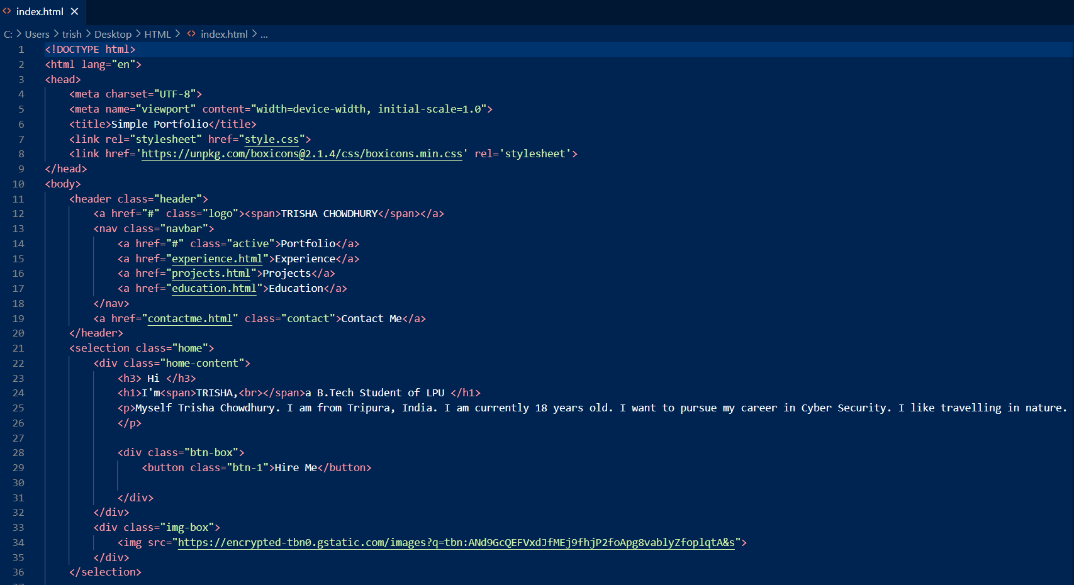

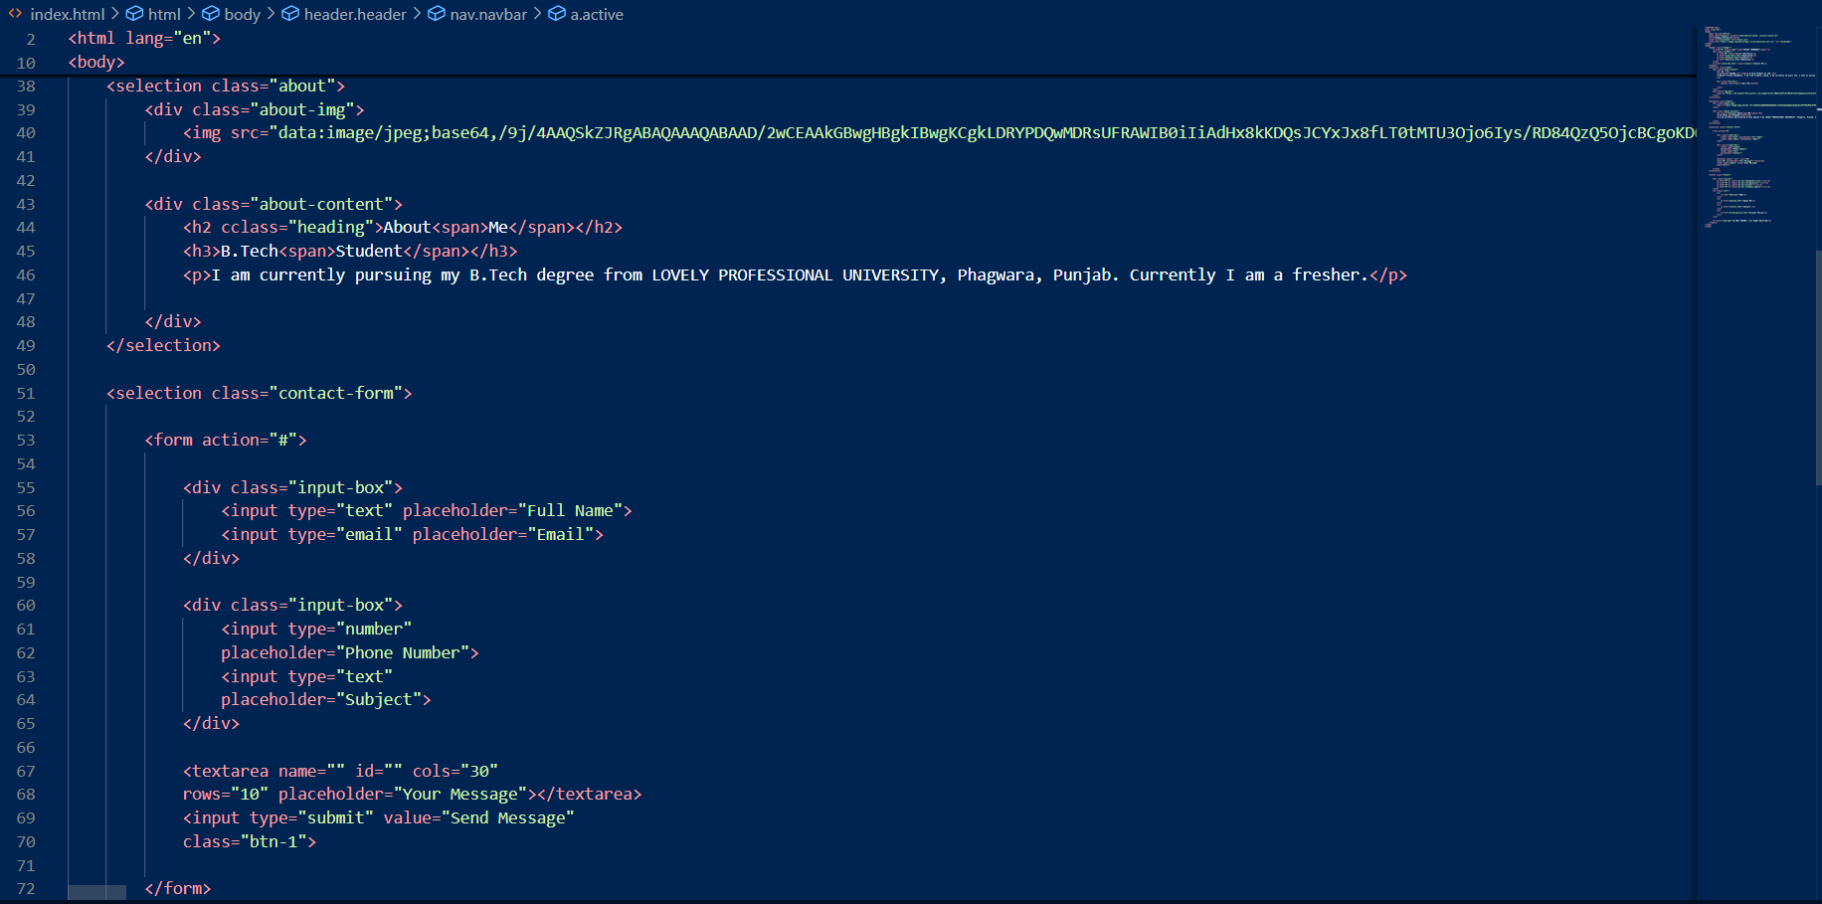

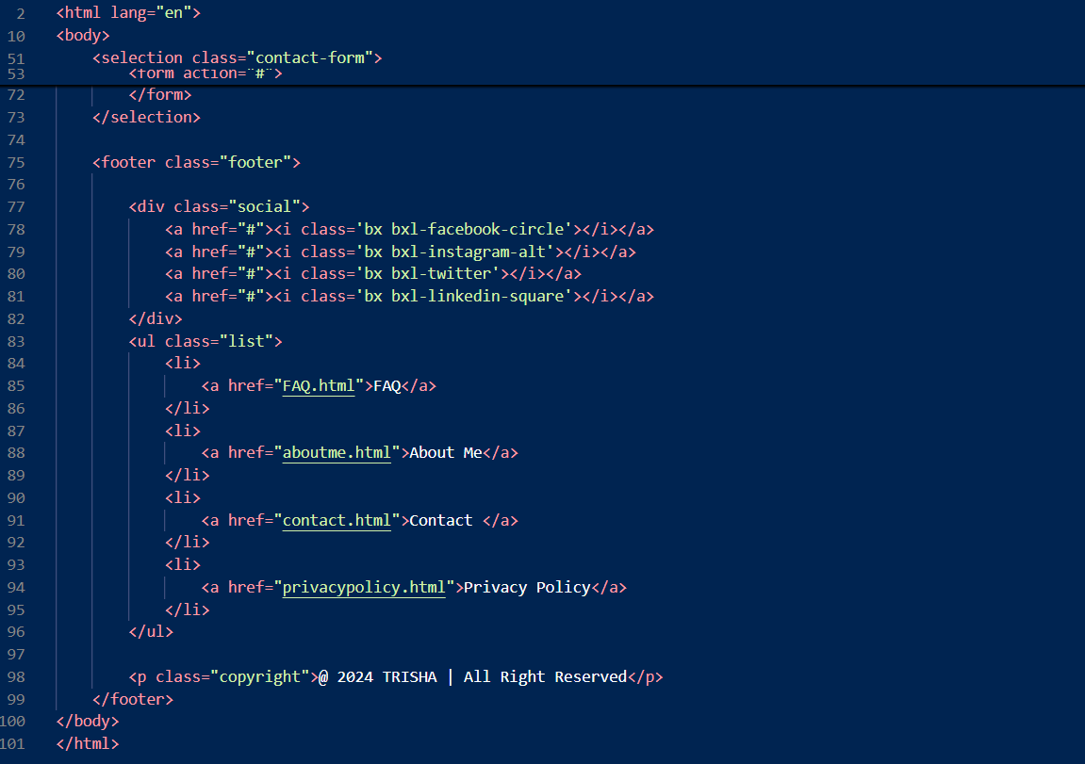

**CSS Code of Home Page:**

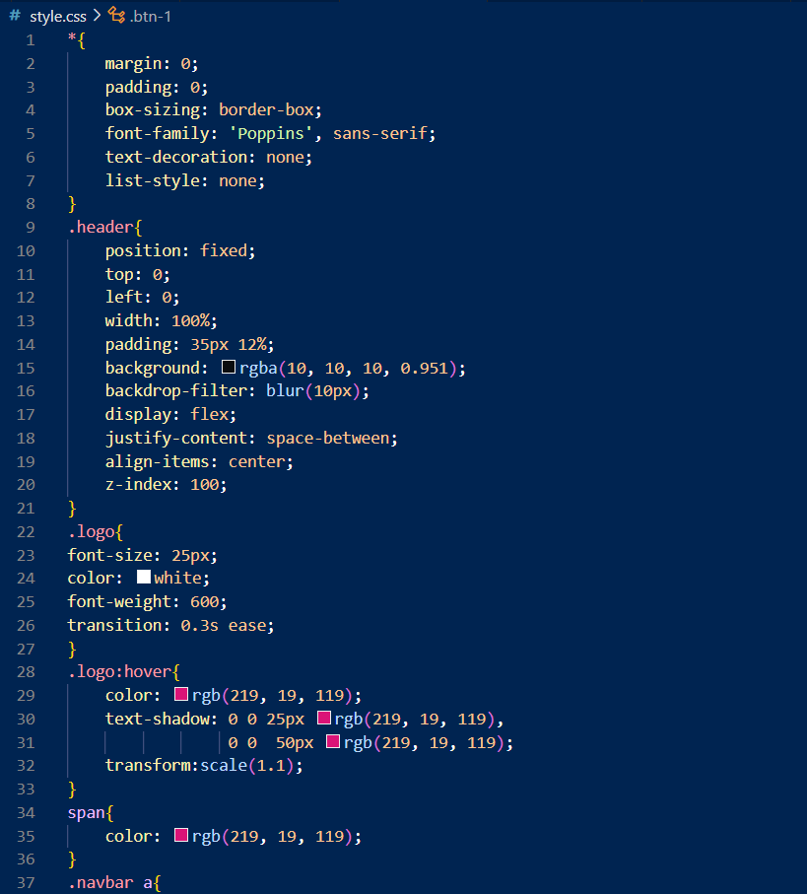

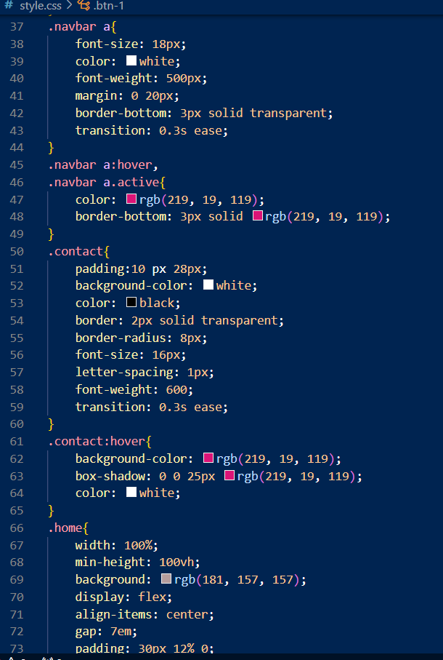

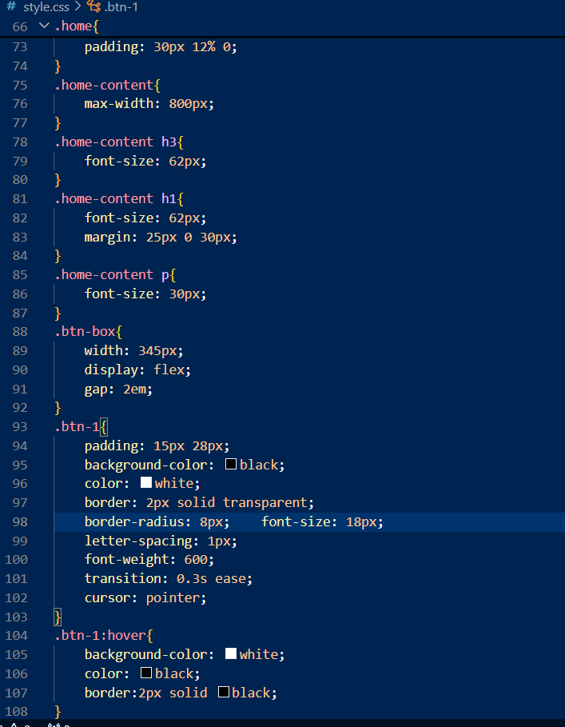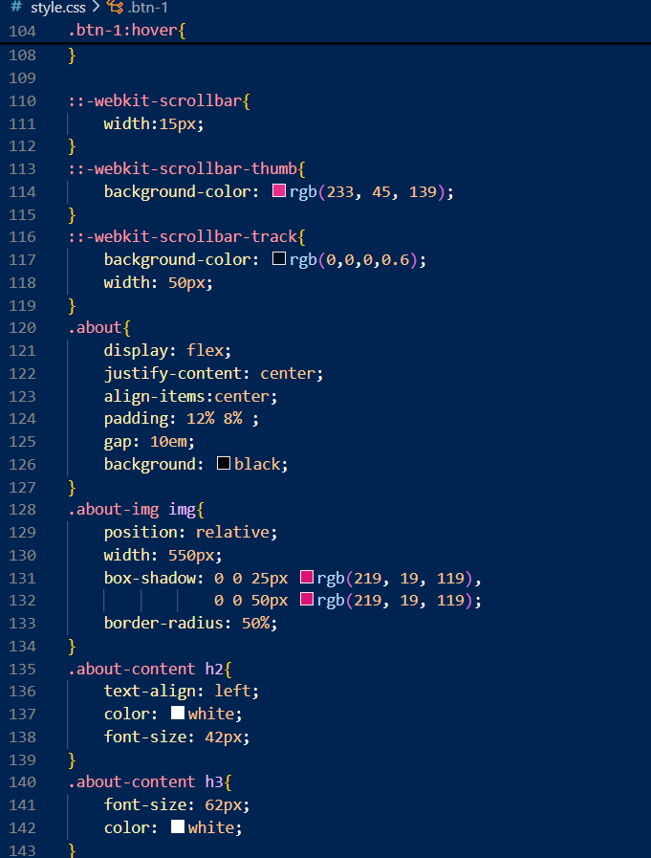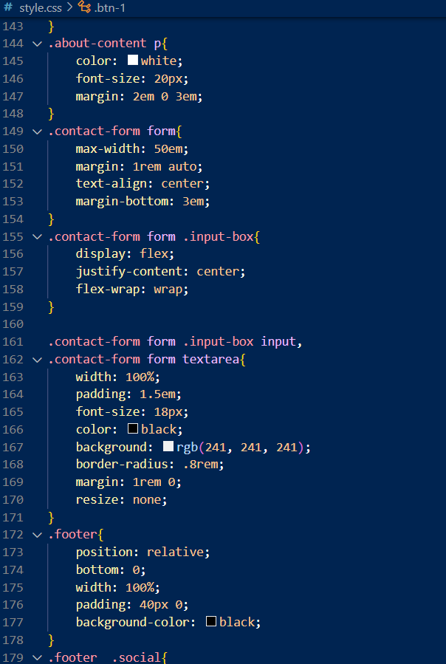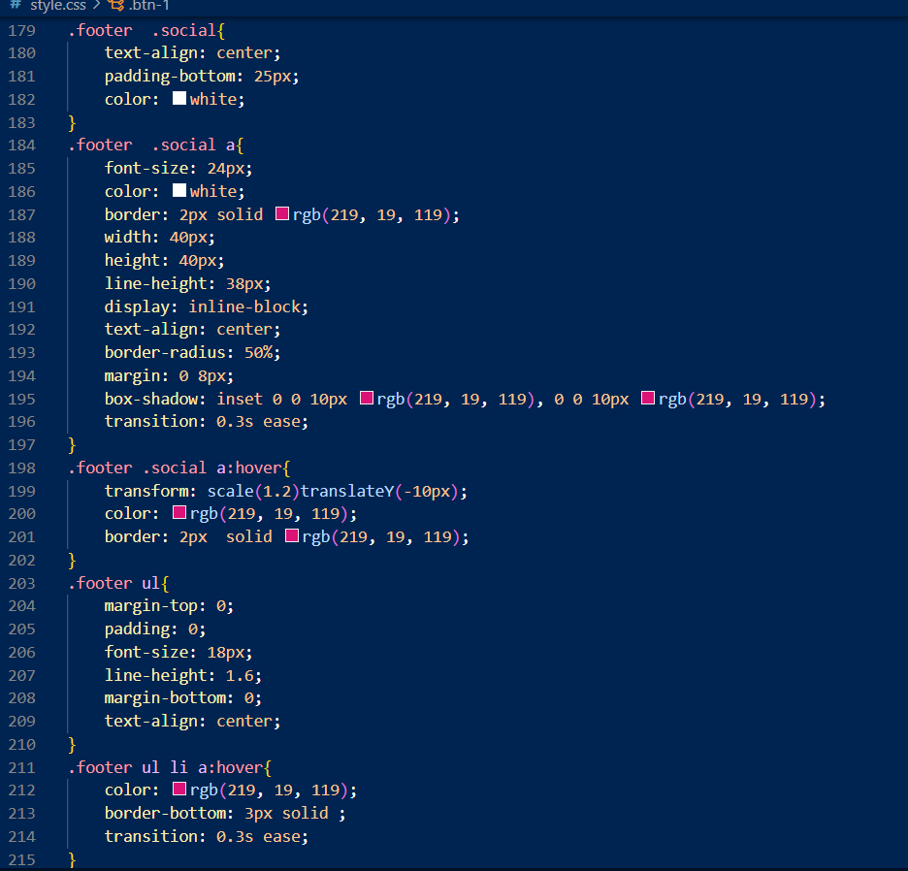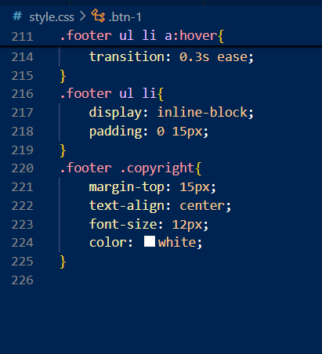

**Output:**

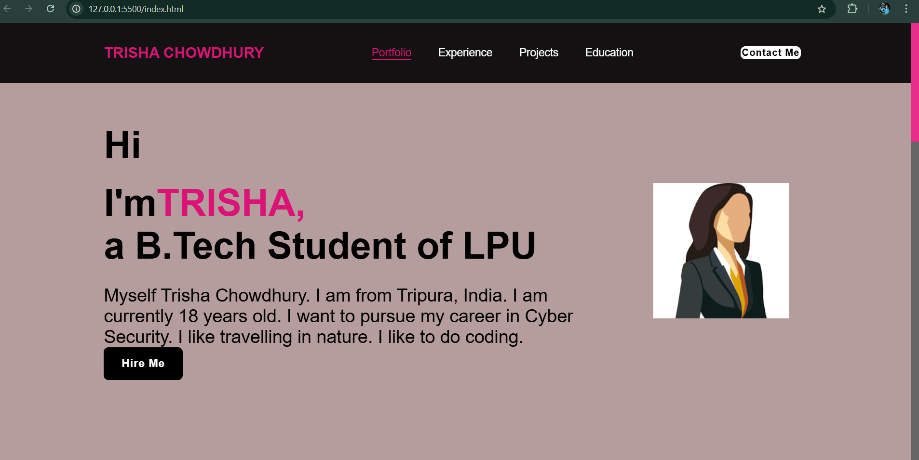

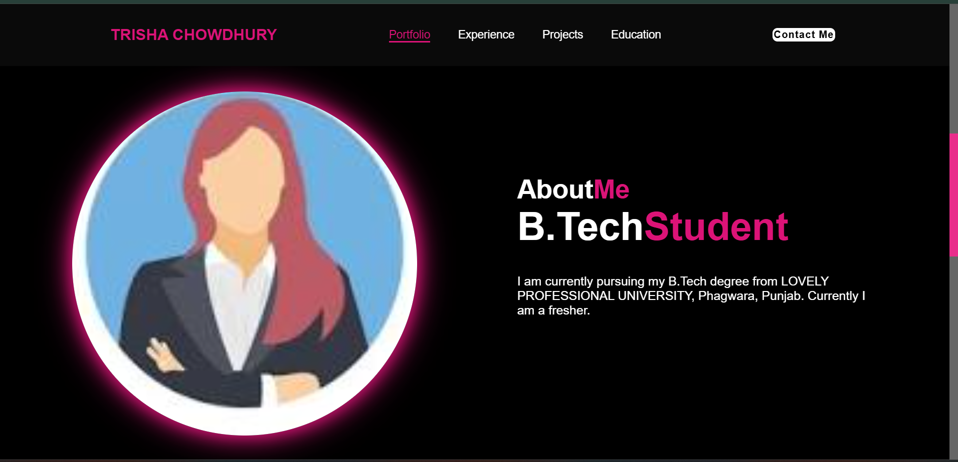

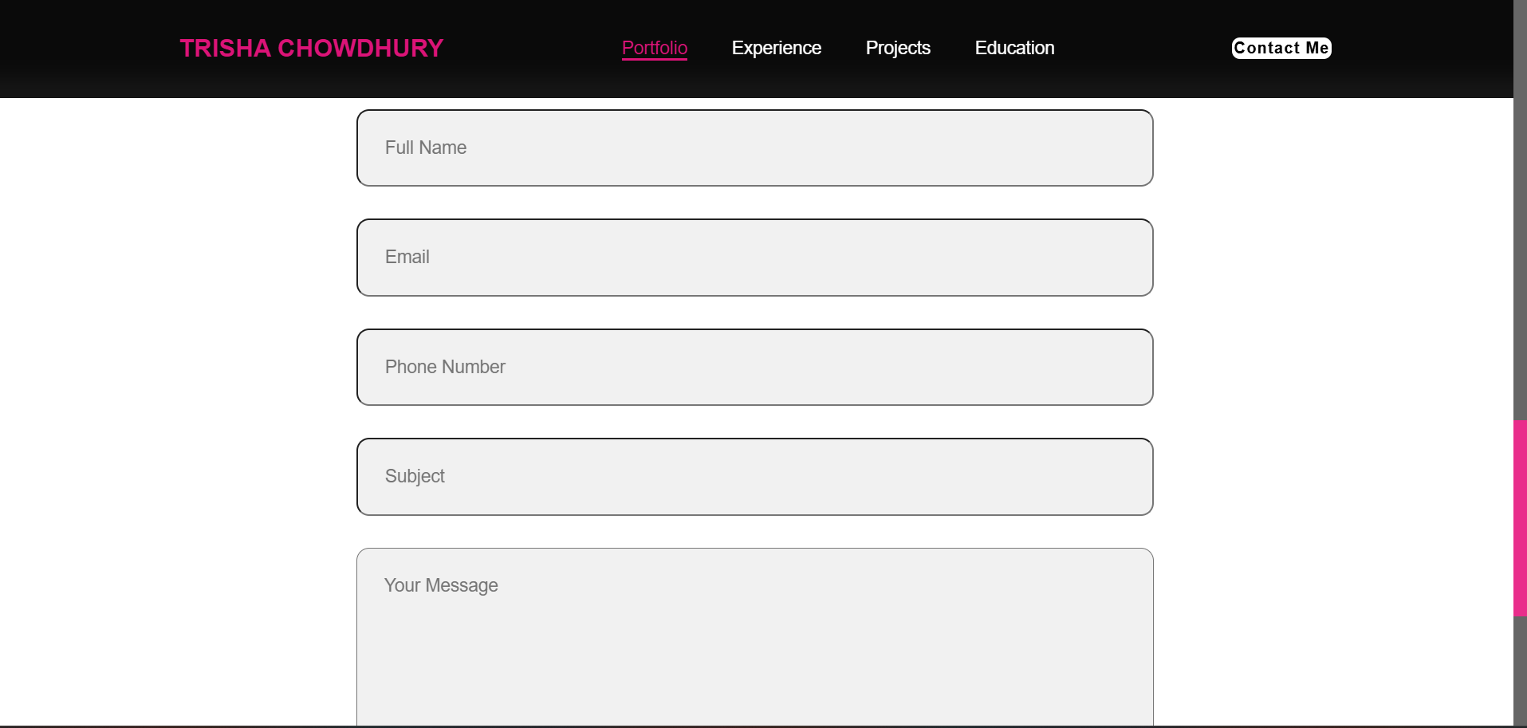

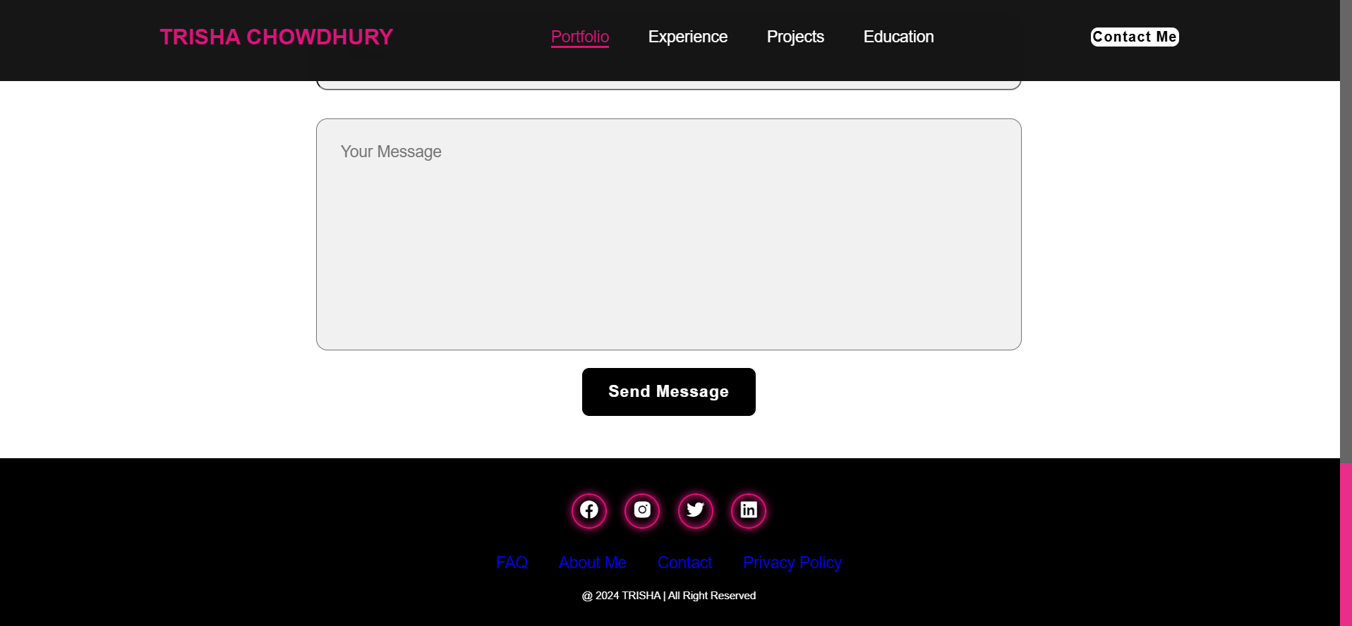

**Conclusion:**

In summary, this portfolio encapsulates the journey, progress, and key achievements accomplished during this period. It showcases the development of essential skills, critical problem-solving abilities, and the successful completion of various projects that demonstrate both technical expertise and creative thinking. The challenges encountered provided valuable lessons, contributing to a deeper understanding and a more refined approach to future tasks. Reflecting on this experience has underscored the importance of adaptability, continuous learning, and proactive engagement in projects. Moving forward, the goal is to leverage these experiences to take on more complex challenges, pursue professional growth opportunities, and continue contributing meaningful work to both personal and collaborative initiatives. This portfolio not only serves as a testament to the progress made but also as a foundation for ongoing development and future successes.

**References:**

* + W3School
  + Previous Projects
  + Chat GPT